Join the NHHS WRESTLING TEAM!
Wrestlers – Managers – Score Keepers
Information Meeting:
Wednesday, October 25, 2017
7:25am in the Main Gym
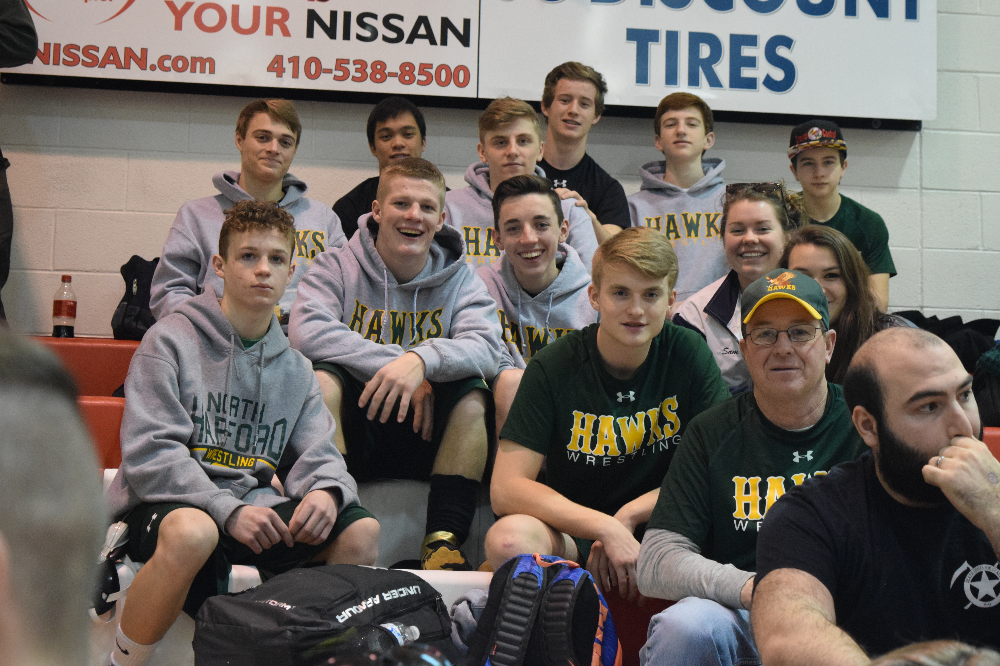
Wrestling is a Winter Sport (November – February)
Participating in wrestling is a great way to stay in condition (or get into condition)!
All Skill Levels Are Welcome
Weight Classes (in pounds):
106, 113, 120, 126, 132, 138, 145, 152, 160, 170, 182, 195, 220 & 285
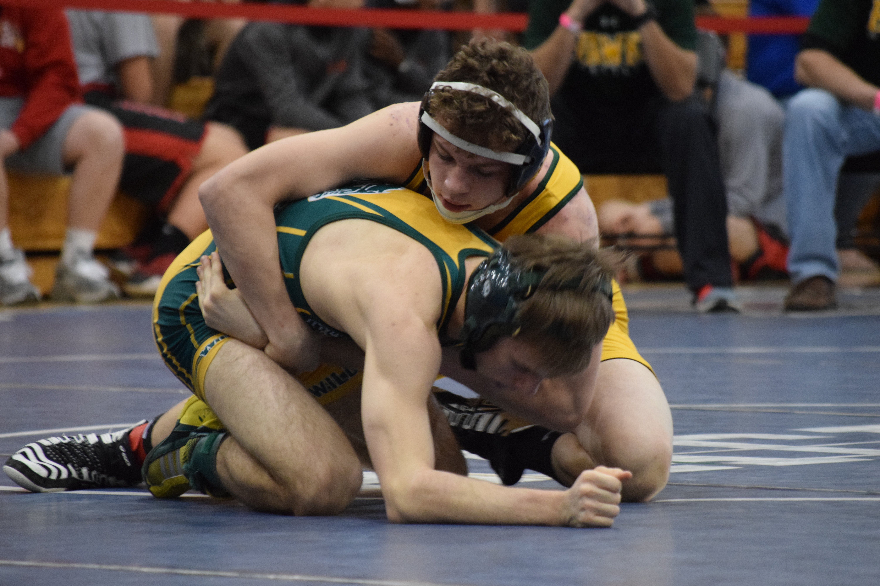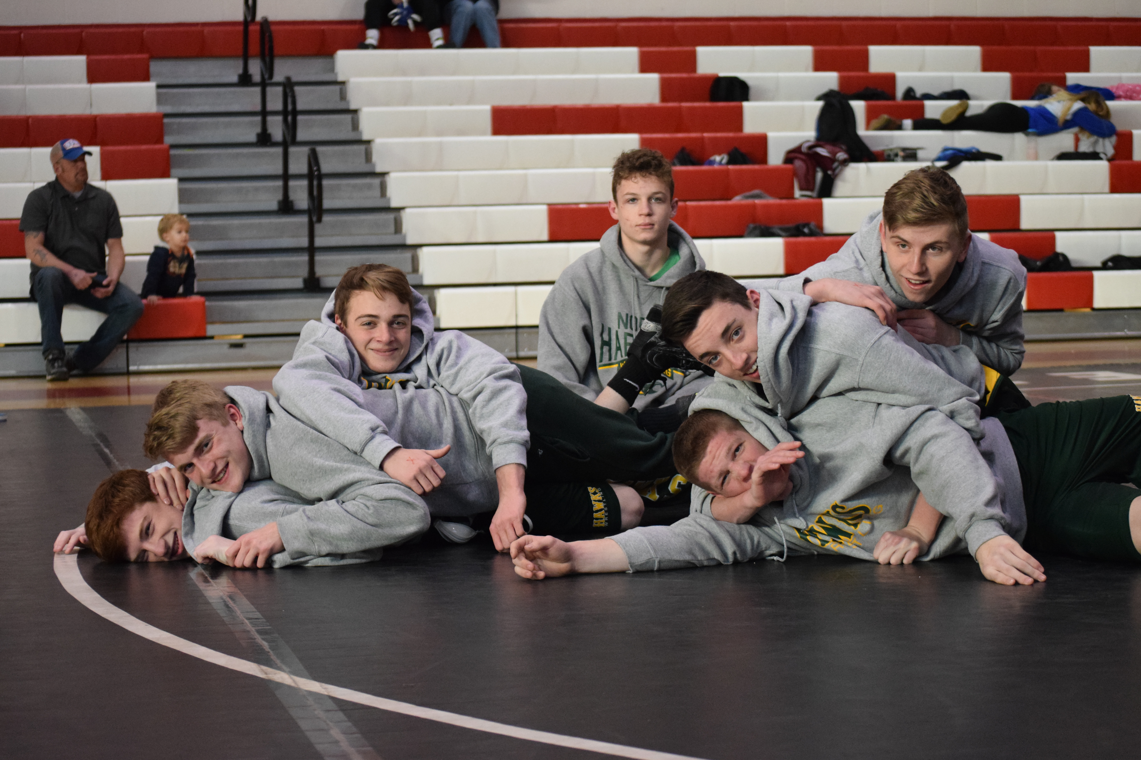
For More Information Contact:
Coach Rob Knox knoxcows@aol.com
Or Returning Sophomore Wrestlers
Josh Mitchell - Anthony Fulco - Tristin Charron - Brennan Stewart

